**Compiler Construction**

**Project Phase # 2: Lexical**

**TINY‐C++:**

This is a subset of C++ language. Description of the language as follow:

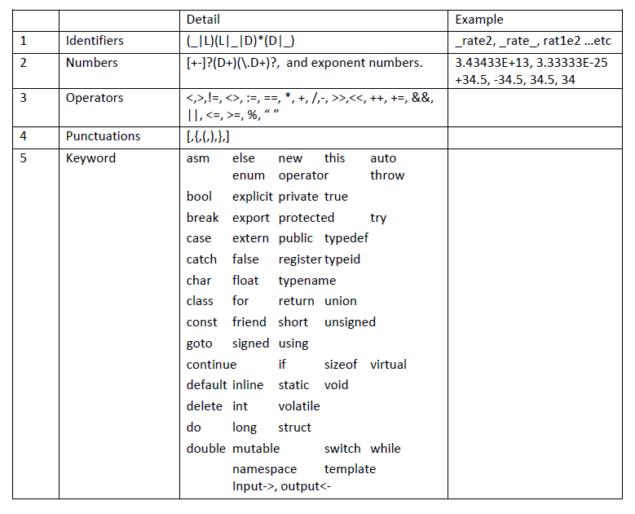

**Grammar:**

Right down grammar for C‐Like syntax

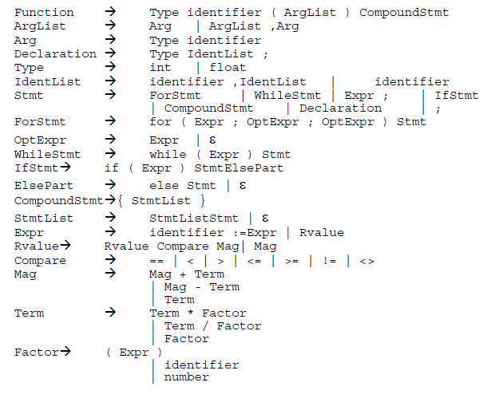

**Description:**

For this Project,

1. Implement the Sub‐Grammar only.
2. You have to write a **Parser** for above Grammar.
3. **Parser** will get **Token** from scanner and built a parse tree.
4. Parser will built the parse tree using Predictive Parser (LL(1)) grammar.
5. **Panic Mode** approach will be implemented to output the syntax error.
6. This assignment includes following parts:

**Tools:**

Language (For Development): C++

**Completion Criteria:**

1. Source code reflect the detail given in documents (other parts).
2. A text file with valid source code will be input of the scanner and Token file will be output of the
3. scanner tool.
4. A text file will show the productions in separate lines used in building the